ClubUML

CSYE7945 Spring 2013

[Sequence Diagram Support]

[Prashant]

[Zessie]

[Yingjie,Wang]

[3/25/2013]

Revision: [1.2]

Table of Contents

Introduction 4

Tools 5

UML Generation Tool 5

Graphing Tool 5

Pic2Plot Installation Guide 6

Pic2Plot Server Side Setup 7

Sequence Diagram Visualization Flow 8

Algorithm Structure Diagram 8

Algorithm Details 8

From Papyrus File to .pic File 9

From .pic File to .png File 13

Implementation Class Diagram 15

Implementation Details 16

# Introduction

In order to integrate sequence diagram in existing system, this document demonstrates the feasibility of integration.

# Tools

## UML Generation Tool

Papyrus

Papyrus Sequence Diagram tutorial:

<http://www.eclipse.org/papyrus/usersTutorials/resources/PapyrusTutorial_OnSequenceDiagrams_v0.1_d2010100.pdf>

## Graphing Tool

UMLGraph

Pic2Plot

# Pic2Plot Installation Guide

**Download Path:**

<http://gnuwin32.sourceforge.net/packages/plotutils.htm>

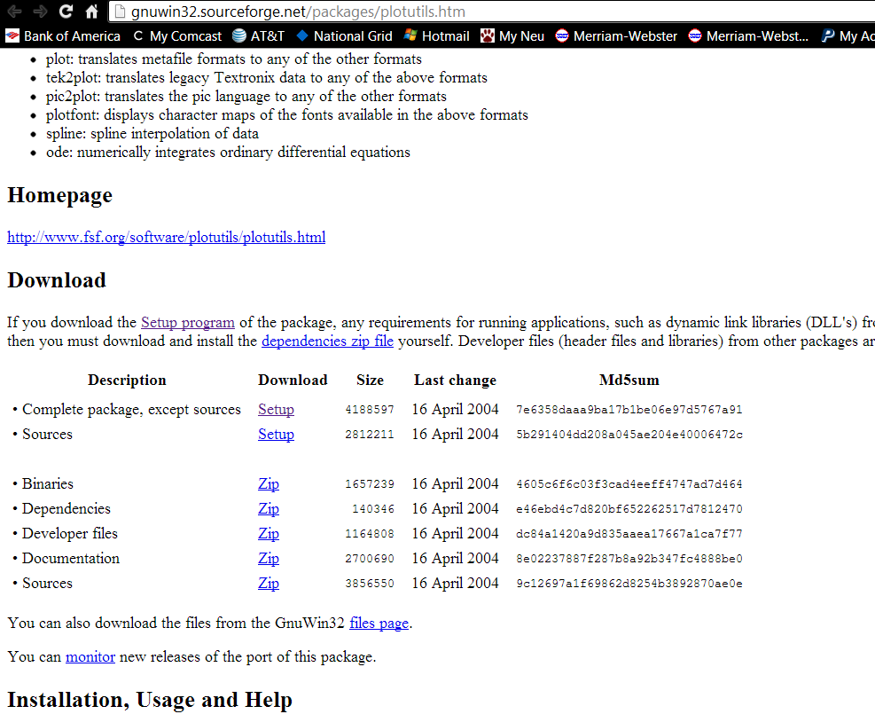

**Set Up Environment Variable:**

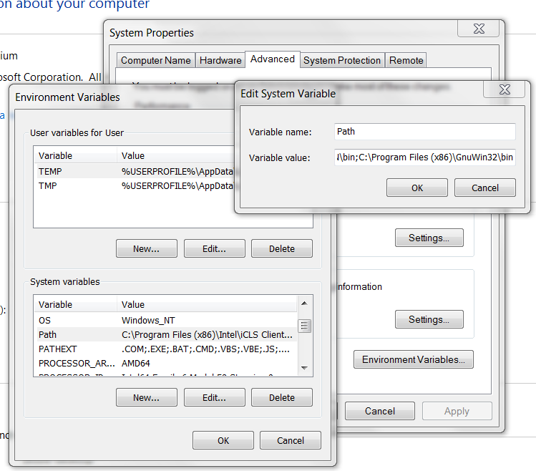

# Pic2Plot Server Side Setup

The pic2plot program has been put under E:\clubuml2012\trunk\ClubUMLSpring2013\tools\ and has been checked into SVN. 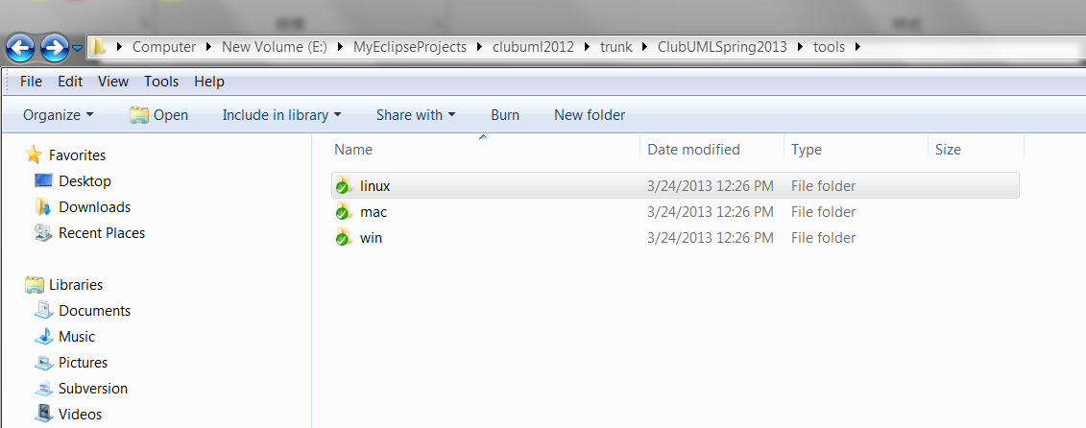

## 

# Sequence Diagram Visualization Flow

## Algorithm Structure Diagram

It starts from parsing papyrus uml files to generate .pic statement and .pic file and then convert .pic file into .png file through pic2plot program.

# 

**Papyrus**

**.di file +.notation file +.uml file**

# 

# Algorithm Details

**UML Graph**

.png File

**Pic2Plot Program**

**.pic File**

## From Papyrus File to .pic File

Once we have the original papyrus sequence files, we can create a .pic file which defines the sequence diagram in textual format.

**Papyrus Sequence Diagram Project:**

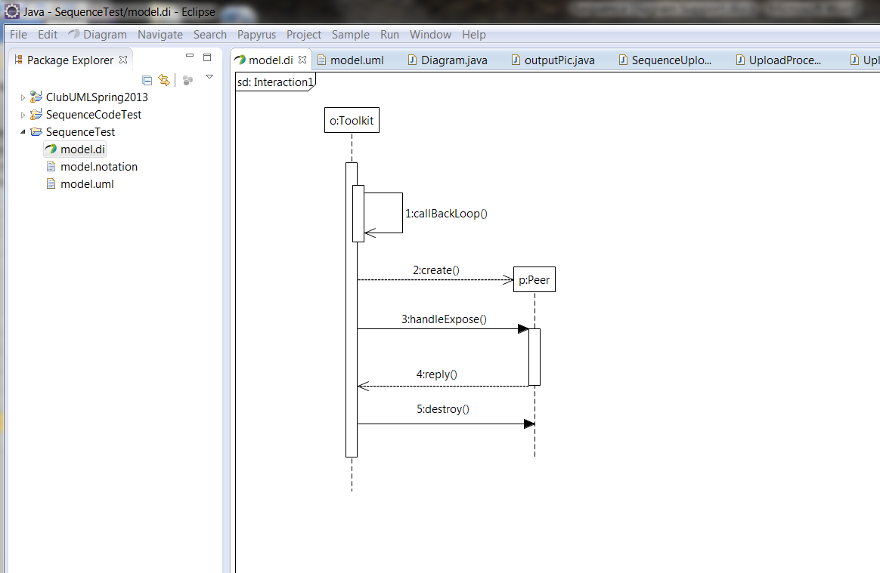

**Fragment**

**Lifeline**

**Message**

**Model.uml File:**

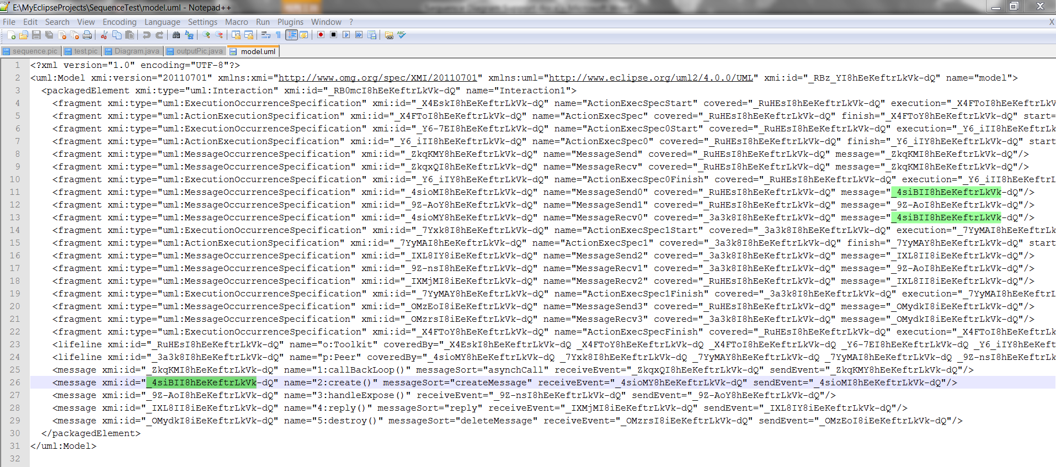

**Relationship between Message, Fragment, Lifeline:**

<?xml version="1.0" encoding="UTF-8"?>

<uml:Model xmi:version="20110701" xmlns:xmi="http://www.omg.org/spec/XMI/20110701" xmlns:uml="http://www.eclipse.org/uml2/4.0.0/UML" xmi:id="_RBz_YI8hEeKeftrLkVk-dQ" name="model">

<packagedElement xmi:type="uml:Interaction" xmi:id="_RB0mcI8hEeKeftrLkVk-dQ" name="Interaction1">

<fragment xmi:type="uml:MessageOccurrenceSpecification" xmi:id="_4sioMI8hEeKeftrLkVk-dQ" name="MessageSend0" covered="_RuHEsI8hEeKeftrLkVk-dQ" message="_4siBII8hEeKeftrLkVk-dQ"/>

<fragment xmi:type="uml:MessageOccurrenceSpecification" xmi:id="_9Z-AoY8hEeKeftrLkVk-dQ" name="MessageSend1" covered="_RuHEsI8hEeKeftrLkVk-dQ" message="_9Z-AoI8hEeKeftrLkVk-dQ"/>

<fragment xmi:type="uml:MessageOccurrenceSpecification" xmi:id="_4sioMY8hEeKeftrLkVk-dQ" name="MessageRecv0" covered="_3a3k8I8hEeKeftrLkVk-dQ" message="_4siBII8hEeKeftrLkVk-dQ"/>

<fragment xmi:type="uml:ExecutionOccurrenceSpecification" xmi:id="_7Yxk8I8hEeKeftrLkVk-dQ" name="ActionExecSpec1Start" covered="_3a3k8I8hEeKeftrLkVk-dQ" execution="_7YyMAI8hEeKeftrLkVk-dQ"/>

<lifeline xmi:id="_RuHEsI8hEeKeftrLkVk-dQ" name="o:Toolkit" coveredBy="_X4EskI8hEeKeftrLkVk-dQ _X4FToY8hEeKeftrLkVk-dQ _X4FToI8hEeKeftrLkVk-dQ _Y6-7EI8hEeKeftrLkVk-dQ _Y6_iIY8hEeKeftrLkVk-dQ _Y6_iII8hEeKeftrLkVk-dQ _ZkqKMY8hEeKeftrLkVk-dQ _ZkqxQI8hEeKeftrLkVk-dQ _4sioMI8hEeKeftrLkVk-dQ _9Z-AoY8hEeKeftrLkVk-dQ _IXMjMI8iEeKeftrLkVk-dQ _OMzEoI8iEeKeftrLkVk-dQ"/>

<lifeline xmi:id="_3a3k8I8hEeKeftrLkVk-dQ" name="p:Peer" coveredBy="_4sioMY8hEeKeftrLkVk-dQ _7Yxk8I8hEeKeftrLkVk-dQ _7YyMAY8hEeKeftrLkVk-dQ _7YyMAI8hEeKeftrLkVk-dQ _9Z-nsI8hEeKeftrLkVk-dQ _IXL8IY8iEeKeftrLkVk-dQ _OMzrsI8iEeKeftrLkVk-dQ"/>

<message xmi:id="_ZkqKMI8hEeKeftrLkVk-dQ" name="1:callBackLoop()" messageSort="asynchCall" receiveEvent="_ZkqxQI8hEeKeftrLkVk-dQ" sendEvent="_ZkqKMY8hEeKeftrLkVk-dQ"/>

<message xmi:id="_4siBII8hEeKeftrLkVk-dQ" name="2:create()" messageSort="createMessage" receiveEvent="_4sioMY8hEeKeftrLkVk-dQ" sendEvent="_4sioMI8hEeKeftrLkVk-dQ"/>

</packagedElement>

</uml:Model>

**Algorithms of conversion from papyrus files to .pic file:**

1. **Define Messages:**

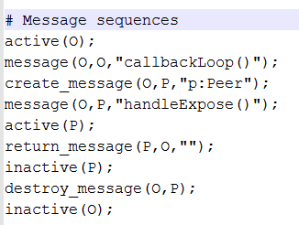

**Lifeline ID**

**Receive Lifeline**

**[lifeline name]**

**MsgID**

**Fragments**

**[message]**

**[covered]**

**Message**

**[message type]**

**[message name]**

**Send Lifeline**

**[lifeline name]**

**Lifeline ID**

**Message Sequence**

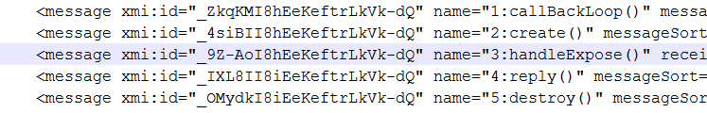

1. **Define Objects and PlaceHolder_Objects:**

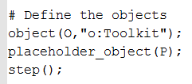



All the lifelines should be objects or placeholder_objects. In order to define one lifeline to be an object or placeholder_object, we have to check the messageSort value.

For example:

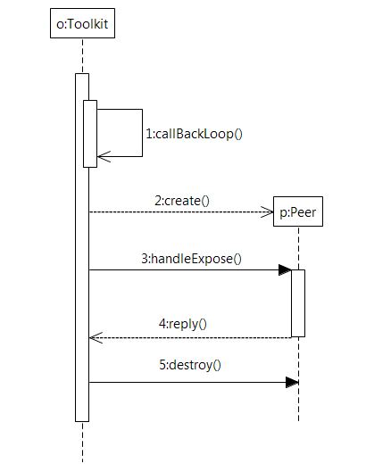



There is one create() message between o:Toolkit and p:Peer, the message type is createMessage, then the message receiver (p:Peer) should be a placeholder_object instead of an object.

## From .pic File to .png File

**Test Folder Before Execution:**

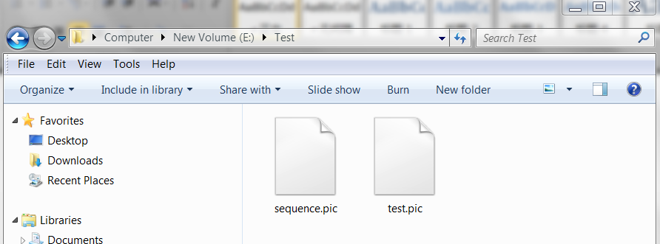

**.Pic Definition File:**

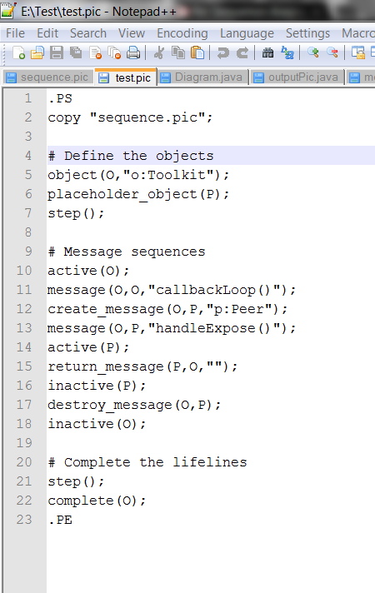

**Execution Command Line:**

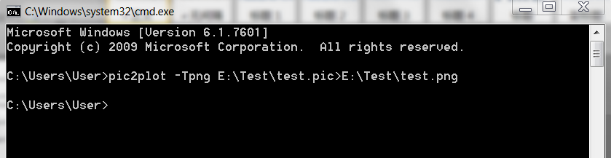

**Test Folder After Execution:**

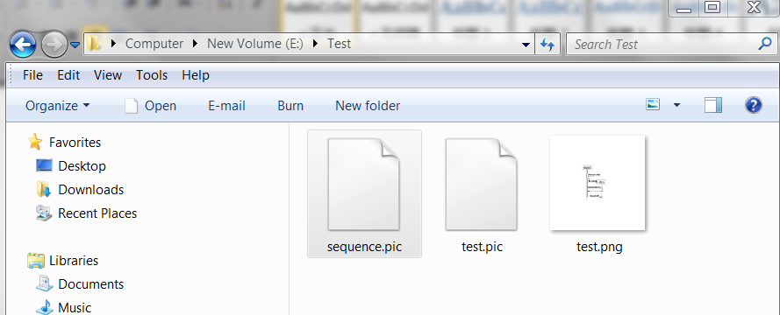

**.PNG Display File**

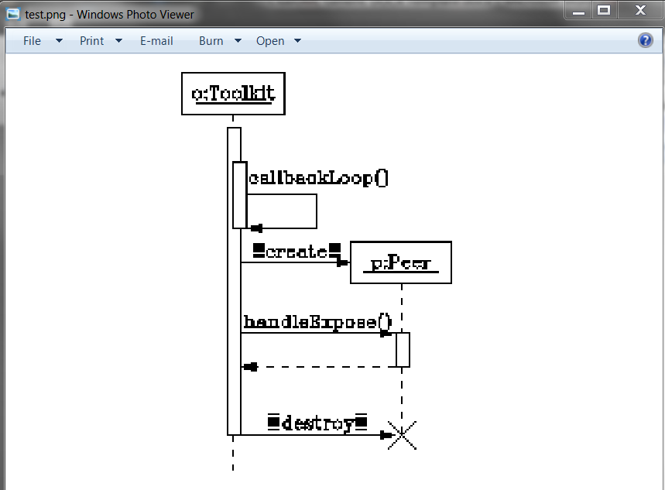

# Implementation Class Diagram

# 

# Implementation Details

1. Add sequence diagram support in process() method of UmlUploadProcessor 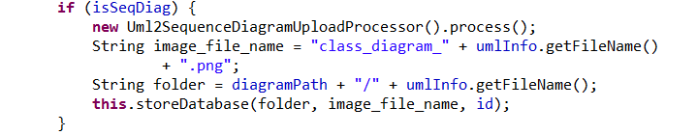
2. Calls Uml2SequenceDiagramUploadProcessor process() method:

* Find Active Element List

Create Fragment xmiElement list

Create Lifeline xmiElement list

Create Message xmiElement list

* Create xmiElementLifeline and add into picElement instance
* Create xmiElementMessage, set sender lifeline and receiver lifeline and sort message into correct order then add into picElement instance
* Create xmiElementFragment and add into picElement instance

1. Calls createPicFile() method:

Pass picElement instance into the method, read it and create .pic statement

1. Calls createPngFile() method of DiagramVisualization to generate the .png file

*** Code has been checked into SVN ***